

**Remade Data Visualisation can be view on Tableau Public here: (Tableau public Viz link)**

**Overview**

**Mapping clarity vs aesthetics**

The chart provided in the DataViz Makeover assignment 1 overall looks somewhat aesthetically pleasing, but is unclear on the details of the chart. Based on this, the chart falls into Quadrant IV of the matrix:

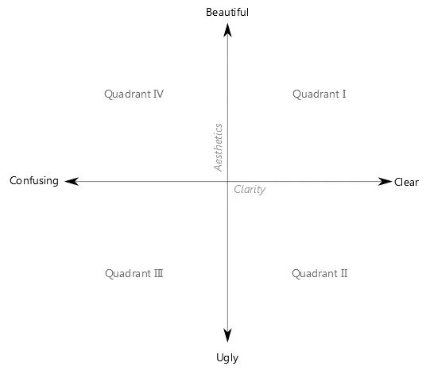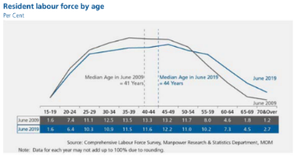

1. **Critique of the visualization and suggested improvements**
2. Clarity:

|  |  |  |
| --- | --- | --- |
| **#** | **Critique** | **Suggestions for improvement** |
| 1 | **Unclear subtitle.** It is not clear what the subtitle “Per Cent” refers to. It looks to almost be put there as an afterthought. | **Remove the subtitle** altogether and label the appropriate axis with “%”. This will reduce extra text, and still present the percentage values in a more intuitive manner. |
| 2 | **X-axis is not explained**. There are no labels to explain what the three types of values on the x‑axis mean. | **Pivot the data** such that the percentages are on the x-axis and the age group is on the y-axis, and label the axes accordingly. This will improve the clarity of the visualisation. |
| 3 | **Unclear presentation of age group information**. It would be clearer if percentage was presented on the y‑axis instead of the x‑axis, as the x‑axis is usually used to present time period. Together with the blue and grey lines in the line graph, it intuitively looked as though to present as a timeline; only upon further examination was it understood to be meant to present age proportion in percentage. | **Pivot the data** such that age group is presented on the y‑axis, as the x‑axis is usually used to present time period. This will make the visualization more intuitive to the reader. |
| 4 | **Duplicate presentation of information**. The two lines in the line graph essentially present the same information as the percentage values for June 2009 and June 2019 in the x-axis. The line graph provided the visual trend, while the percentage values in the a-axis provided the actual percentage values. This duplication would not be needed with better visualization design. | **Remove the June 2009 and June 2019 percentage values on the x-axis.** This will no longer be necessary once the data is pivoted appropriately. |

1. Aesthetics:

|  |  |  |
| --- | --- | --- |
| **#** | **Critique** | **Suggestions for improvement** |
| 1 | **Good use of colour to differentiate the 2 time periods**. A more contrasting colour scheme might be better. | **To use 2 better colours** to enhance the contrast and clarity of the 2 sets of data being compared. |
| 2 | Clear labelling of what the two lines in the line graph represent, and the median ages. However, better designed aesthetics could allow for more concise labels (use less words). | Include labels as necessary |
| 3 | With 3 different values, the x-axis is too cluttered. | This will be solved when the data is pivoted appropriately, as mentioned above. |
| 4 | As a minor point: although best practice states that number ranges should start with 0, there is no need for the age group to start from 0 as this graph is to present the labour force which is consists of all persons aged 15 years and over (<https://stats.mom.gov.sg/SL/Pages/Labour-Force-Introduction.aspx>). The age group still covers the entire range of legal working age ranges so it is sufficient. | No action necessary. |

1. **Sketch an alternative visualization**

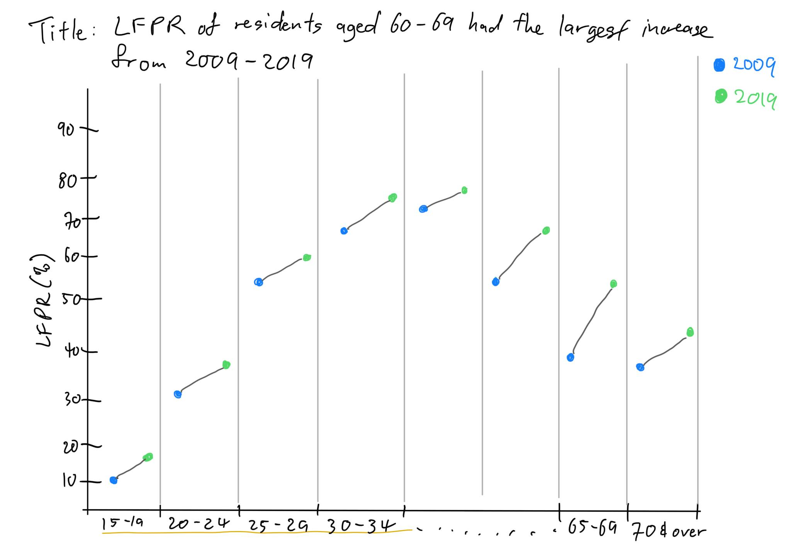

1. **Build the visualization**

|  |  |  |  |
| --- | --- | --- | --- |
| **#** | **Tab** | **Step** | **Action** |
| 1 | Data Source | Import data | Import Excel file to Tableau |
| 2 |  | Cleaning data | The data is not standardized and clean, because the formatting of the spreadsheet is not friendly for data importation.    Clicking on the “Cleaned with Data Interpreter” will clean up the data significantly and allow for easier cleaning.    Hide the left-most column as it is not useful.    Rename “Age (Years) 1” column to “Age Group”    Check that “Age” column is of the correct data type (string).    Check that the rest of the year columns are of the correct data type (Number[decimal]). |
| 3 | Sheet | Chart creation | 1. Drag “2009” and “2019” to the Columns pane. 2. Drag “Age Group” to the Rows pane.      1. Exclude NULL and Total columns from the chart. 2. Exclude overlapping age groups.      1. Sort Age Group in descending order. 2. Select “Dual Axis” to combine the two charts into one.      1. Select “Synchronise Axis” to ensure both charts’ axes are uniform.      1. Remove “Show Header” to show only one axis.      1. Change 2019 Mark to Bar chart.      1. Swap “SUM(2019)” to the front in order to display the 2009 chart in front of 2019 chart.      1. Edit the range of the x-axis to show 0% - 100%, and rename label as “LFPR (%)”.      1. Change the view to “Entire View” for clarity.      1. Change title of chart.      1. Change title of legend to “Year”      1. Rename Sheet      1. The final chart would look like this: |

1. **Some key observations**
2. The 25 to 29 age group had the highest LFPR in 2009. Ten years later in 2019, the age group with the highest LFPR was 30 to 34.
3. The largest increase in LFPR from 2009 to 2019 is amongst the 50 to 64, and 65 to 69 age groups. This is expected of a an ageing population (<https://stats.mom.gov.sg/Pages/Labour-Force-In-Singapore-2019.aspx>).
4. Of all the LFPR age groups, only the 20 to 24 age group declined in LFPR from 2009 to 2019. This is the only exception amongst all the LFPR age groups.
5. The lower the age group, the lower the increase in LFPR from 2009 to 2019, with the exception of the 15 to 19 age group, which seemed to reverse the trend compared to the next older age group. This seems to contradict Singapore’s Total Fertility Rate (TFR) has been declining (<https://www.singstat.gov.sg/modules/infographics/total-fertility-rate>) consistently, but may have been bolstered by the slight up-tick in TFR in 2000.